Smart Tracking Watch
User Manual
Content
Content 2
1.Product Overview Error: Reference source not found
1.1 Overall description 3
1.2 Smart Tracking Watch Features 3
2. Attention 3
3. Technical specifications 3
4. Introduction Of Products 4
4.1 Appearance and Key Descriptions 4
4.2 Screen icon Descriptions 4
5.Fast use guide 5
5.1 SIM card installation 5
5.2 Accessory 6
5.3 Setting the number of guardian 6
5.4 Restore factory setting 6
6.Mobile phone SMS inquiry guide 6
7.PC-WEB service platform 8
7.1 Log in 8
7.2 O NLINE Monitoring 9
7.3 Track playback 11
7.4 Self-Service 11
7.5 Report Statistic 12
8. Fault and solution 13

1. Product Overview

1.1 Overall description
Smart Tracking Watch except the basic functions of calling, send and receive SMS, take photo by camera and so on, also can send the location information to mobile mobile and computer quickly by sending SMS or through GPRS. It can get the tracker location information by online service platform(web or C/S) or mobile mobiles.。

1.2 Smart Tracking Watch Features
- Real-time monitoring of target last position  - Smart base station position  - GPRS signal strength display  - Geo- fence  - 5.Playack history track | - 6.Remote monitoring  - 7.Target location query message  - 8.Self-service platform PC (compatible with B / S and C / S)

2. Attention
Before using this product, please read the instructions in this section:

- Make sure the SIM card is a standard GSM network card
- Ensure that the SIM card GPRS functionality, we recommend using the GPRS package (save the bill)
- Make sure the account of SIM card hasenough money
- Make sure the SIM card does not set a password (PIN1, etc.)
- Check the SIM card SMS account, if full, proposed to delete some, othewise can not receive SMS.
- Check the SIM card is opened the Caller ID features do not support caller ID feature can not hang up phone calls to find the target location and monitoring functions.
- Contact your carrier for apn information and the correct settings on the device. Access to the factory default apn cmnet
- In the use of PC-WEB platform before, please use the cell phone set up guardians and related instructions.

3. Technical specifications
Name | Parameters
Product Name | “Position Online” Smart Tracking Watch
Battery Voltage | 3.7V
charging voltage | DC5V
size | Appearance of disc diameter 45.84MM / with battery thickness 17.50MM
Operating Temperature | -20℃～+70℃
Storage Temperature | -40℃～+85℃
Working frequency and sensitivity | GSM 850/900/1800/1900 MH  GSM -108dBm /GPRS CS4 -102dBm
Location query mode | B / S or C / S service platform，Mobile phone short message and a variety of ways

4. Introduction of Products

4.1 Appearance and Key Descriptions
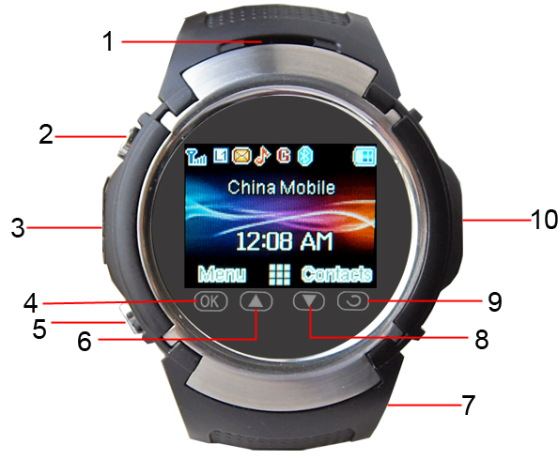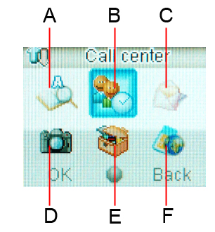
Figure 1: Key Diagram

1：Speaker A：Mobile book (view, add, copy)
2: Switch key, lock screen button. (Long time to switch key) B:Call center (see the records, Call setting)
3：Charging port, headphone jack C：Messages (SMS, MMS, view, send)
4：Confirm key D：Media (photography, video, music, FM, video)
5：Dial / answer the phone button
(long press for sos alarm) E：Setting (Bluetooth, phone settings, security settings）
6：up key F：Network Services
7：Microphone NOTE:
8：down key
9：return key Bluetooth connection password 0000
10：camera
4.2 screen icon Descriptions
Battery charge status Ring mode

Network signal strength Vibration mode

GPRS is available Ring after the vibration

Missed calls Vibration with ringing

Received new message Alarm has been set

Keyboard is locked  Turn on Bluetooth

Music player
This mobile phone built-in music player, can be used to play music repertoire, and music can be set to the bell. Note: MP3 files should be put in the root directory "my music" directory to the play music repertoire display.
Video player
This cell phone video player built-in, can be used to access or deal with the video files stored in players, including video, MP4, 3 GP documents, etc. Note: video files to put the root directory in "Videos" folder to normal play;
Bluetooth
You can directly on to file transfers take with Bluetooth for transmission, to search for transmission equipment, according to the screen can be carried out the operation instructions; Accept data, also choose receiving, file is automatically stored in user Settings directory.
Photo / video
Photos: you can use the mobile's built-in cameras and can adjust its setting photos. The photo will be saved in the mobile phone to own the file system, photographs for JPG format.
In taking pictures preview interface press the ok button into the camera Settings can be set for the camera, set up after the completion of the save camera setting. When you choose good after photographing the scene, according to the touch screen key navigation key or by the middle of the definite key shoot. At this time would ring shutter voice, to ensure that the picture quality, please keep the camera steady still for a moment. After the completion of the shooting showed on the screen of mobile phone of shoot the static scenery (when a state called frames state)
Video: in the video interface，According to the up and down the direction key adjustable focal length，according to the or so direction key adjustable exposure compensation, also can enter the "options" menu is related to the video, set up and keep, click "ok button" video, in the video according to defined in the process of the key to suspend the recording, according to the right softkey to stop recording.

5. Fast use guide
5.1 SIM card installation
Open the watch back cover, into the SIM card, cover watch back cover. (see figure 2)

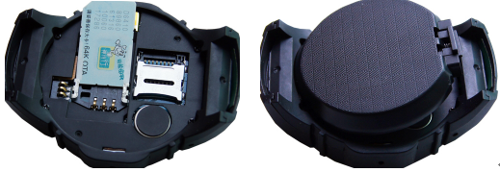

Figure 2:SIM card setting

5.2 Accessory
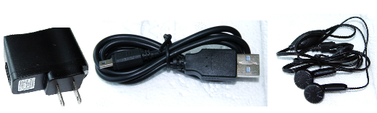

Figure 3 : Accessories

5.3 Setting the number of guardian
The watch can set three guardian number, including a Lord guardian number and two optional guardian number. When long press SOS alarm key, the watch to Lord send relief information and guardian call, if the Lord did not answer the phone call the guardian of the other two guardian phone.
5.4 Restore factory settings
Use this setting to be very careful! , after" restore factory settins" operation, the watch will be back to factory condition (including empty the Guardian number)
Restore factory settings password 1122
6. Mobile phone SMS inquiry guide
Cautions：When Tracking Watch without guardian number. It can receive and process all effective form SMS from any numbers. For protecting security and privacy, suggest to set the guardian number firstly.

The list of SMS command that Tracking Watch can indentify as below:
（1） Set the mobile number of administrator and guardian
Format: Admin, Password, AdminTel,Tel1,Tel2
The default password of Tracking Watch is: 000000. adminTel is the mobilenumber of administrator; Tel1,Tel2 are the moblie number of guardians. After setting , Tracking Watch will automatically send the SMS to the administrator’s mobile number. This command can be set and modified only by the administrator’s mobile number.
Sample: administrator’s mobile number send such kind of SMS :
admin,000000,15960008888, 15960008887, 15960008886
to SIM card number in Tracking Watch, then 15960008888 will be set as administrator’s mobile number of Tracking Watch. administrator’s mobile number will be same as the main Guardian’s number, 15960008887 will be tel1, 15960008886 will be the tel2. When all setting finished, there will be a SMS back to inform the main guardian.

（2） Setting Tracking Mode
Format: mode, password, interval of realtime tracking, times of return.
Set interval of timing return and frequency of return, interval as 0 means time to time return, frequency as 0 means return the data to “Position Online” Platform with unlimited times. This order just can be set and modified by administer.
For example: administrator’s mobile number send such kind of SMS:
mode,000000，180,0
to SIM card in Tracking Watch, then the Tracking Watch return the data to “Position Online” Platform with unlimited times every 180 secs.
（3）SOS Function
After setting administrator and guardian，long-time pressing SOS button, it will can call(and send the SMS at the same time) to the administrator, when the administrator does not answer or refused to answer the mobile, the watch will call Guardian 1, when Guardian 1 does not answer or refused to answer the mobile, the watch will call Guardian 2.
（4） Call Back
Format: 123 or call
After sending the instruction, the Tracking Watch will call back to the administrator to have a two-way conversation.

For example: The administrator send such kind of SMS:
123
The Tracking Watch will call the number automatically: 15960007788.
(5) Single Time Return (Search Tracking Watch’s position)
Format: 002 or where
For example: The administrator send such kind of SMS:
002
to SIM card in Tracking Watch, the Tracking Watch will reply the position details to the administrator’s number. When administrator call the Tracking Watch ‘s SIM number, and hang up the call after 3 sound effects, reply the position detail, the same as 002 and where SMS instruction query function.

（6）Single Time Roll Name
Format: 001 or gps
Sample: The administrator send such kind of SMS:
001
to SIM card in Tracking Watch, the Tracking Watch will upload the position details to platform.
（7） Monitor Order
Format: 321 or monitor
After sending the instruction, the Tracking Watch will call back to the administrator to have a one-way conversation. The administrator can monitor the sound around the Tracking Watch.
Sample: The administrator send such kind of SMS:
321
The Tracking Watch will call back to this number automatically: 15960007788.
（8）Change Password
Format: 000, original password, new password or key. Original password, new password.
Sample: The administrator send such kind of SMS:000,000000,123456
To SIM card in Tracking Watch, change the password as 123456. The factory default password is 000000. This instruction only can be set and modified by the administrator’s number.
（9） Set APN
Format: 555, apn, user name, password, or apn, apn, user name, password
Sample: The administrator send such kind of SMS:
apn.cmnet,user,user or 555,apn,user,ser
To SIM card in Tracking Watch, apn set as nocm net, When there is no user name and password can be ignored, The factory default is cmnet, This instruction only can be set and modified by the administrator’s number.

7.PC-WEB service platform

7.1 Log in
Log inWEB services platform, fill in the user name and password and click on the "login", enter the platform interface.
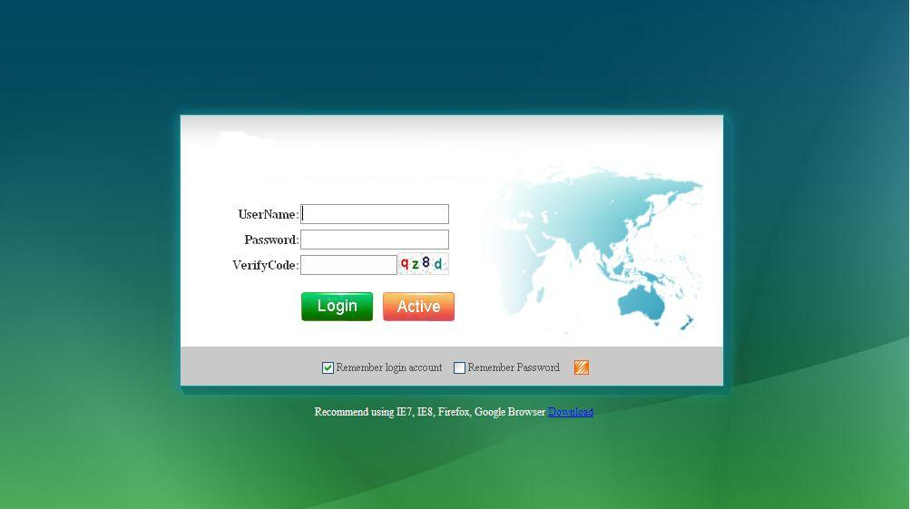
Figure 4: Login interface
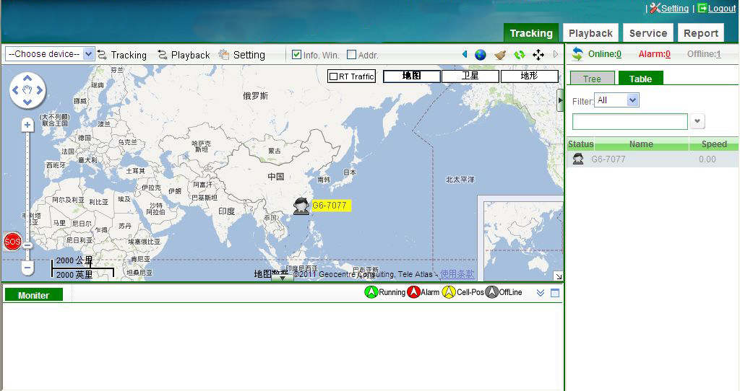
Figure 5 : Main interface

7.2 Online Monitoring
The equipment list on the right, select the name of the query Tracking Watch will display on the map the location of the target date.
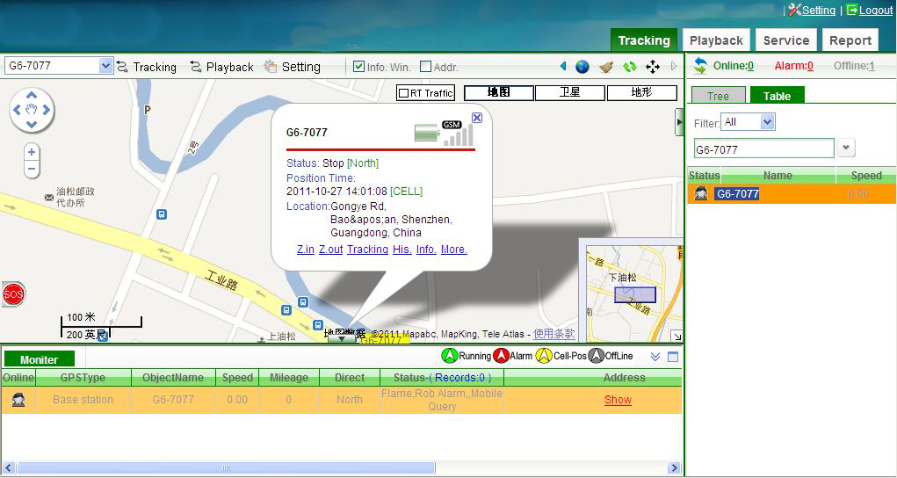
Figure 6: Online monitoring
Easy tips：
- Click the upper right corner of the online / alarms / offline target number, you can filter out the online / warning / offline target list to quickly help you identify the target group.
- Click on the right side of the green on the map POI icons can edit your own points of interest (see Figure 7)
- SOS icon in the lower left corner of the red alert window will guide you to open. Real-time / historical alarms and settings. (See Figure 7)
- You can choose to open the interface below the list of real-time information, while concerned about the status of multiple targets in real time (see Figure 7)
- Bubble window on the target device can choose real-time tracking, track playback, query data, field selection, query history, alarms, etc.
- 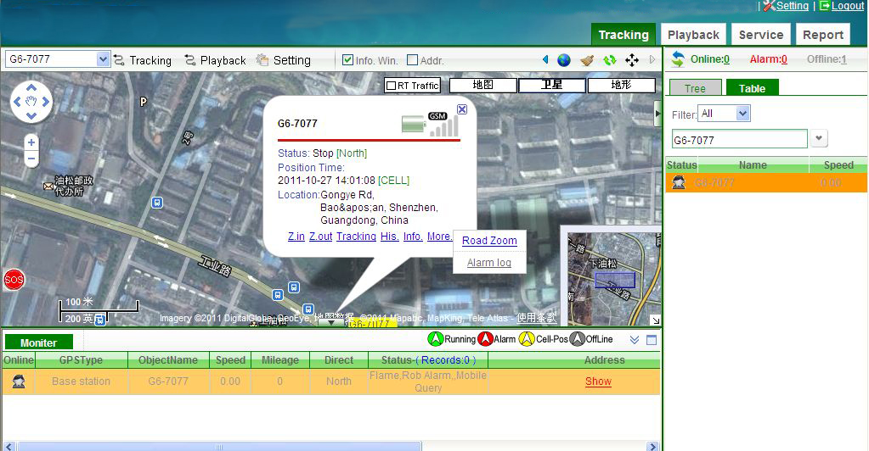
Figure 7: Online monitoring 2

7.3 Track playback
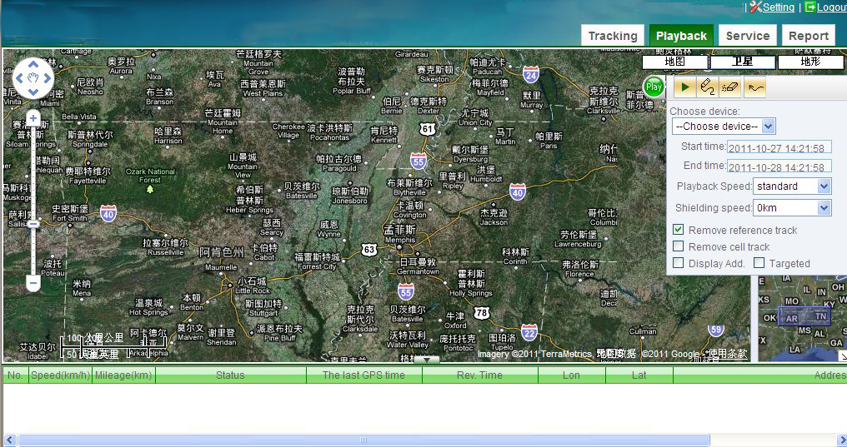
Figure 8: Track playback

7.4 Self-Service
Dealers at all levels according to user need to create lower-level dealers or end users to form a tree management system. (See Figure 9)
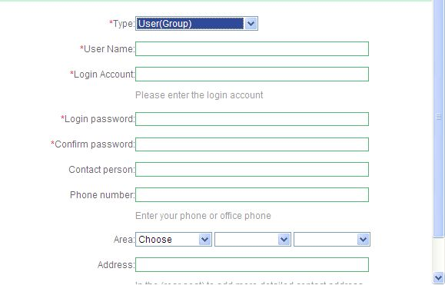
Figure 9: User managerment
Adding new equipment please select Watch Tracking Watch（See Figure 10）
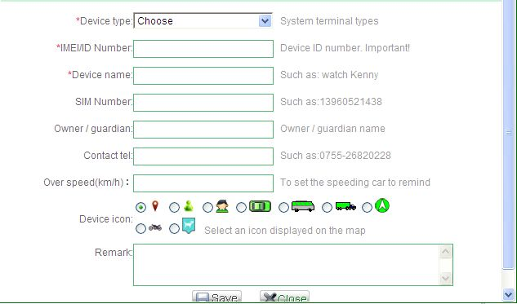
Figure 10: Add new equipment

7.5 Report Statistic
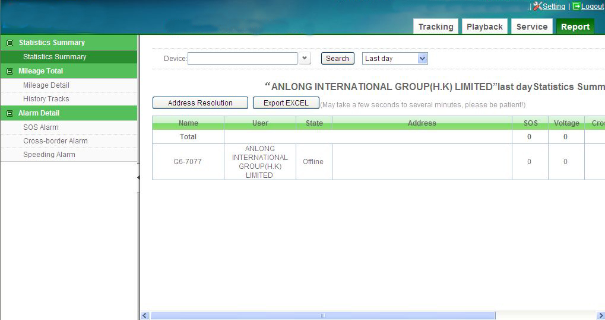
Figure 10: Report Statistic

8. FAQ
Question | Solution
Tracking Watch shows no services after Starting-up | Please check the SIM card if inserted。
Watch cannot callin | Make sure the host SIM card whether open caller ID display
The watch cannot send the location information to the service platform | Please check the account of SIM card
Cannot get online information of Tracking Watch on service platform | Please check the watch operating mode
Send SMS command but without comfirmation by SMS y | Comfirm the SMS Editorial content format is correct, and whether the send way is guardian of the sender number
Report the contents of only a single location with latitude and longitude coordinates, no hot description | Make sure the GPRS transmission failure due to SIM card arrears

